# WORKSHEET 2.2 – Answer Sheet

# Review OOP

1.

1. Class – In OOP, a set of instructions like a blueprint that determines what kind of behaviors and attributes objects have, as well as how to create new instances of those objects.
2. Object – In OOP, a virtual object, created by a program and from a class definition, which interacts with other objects to complete a task.
3. DrawingTool – A class that creates DrawingTool objects to draw patterns on a SketchPad object.
4. SketchPad – The virtual drawing surface that a DrawingTool object marks on.
5. Attributes – Aspects of an object, which describe its current state.
6. Constructors – Special methods that describe how objects are created and often set the initial state of the object.
7. Behaviors – Actions that objects can do. An object should be defined more by what it can do than values that it holds.
   1. They all have draw() methods and they all have a constructor. The draw method creates the appropriate picture. Answers may vary.

3. The pictures were different, so the actual lines of code were different. The class names are different. Answers may vary.

4. A circle centered at the point (0,0) with a radius of 50 with a circumscribed square around the circle.

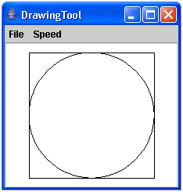

1. marker.up();

marker.home();

marker.down();

marker.drawCircle(115);

Your solution should look like the following.

